**Demo service 1:**

Scenario : The service will carry out all the CRUDQ operations over a custom table. The following objects are used. The approach used to create the service is by redefining the methods of the data provider class.

Table ZEMP_GW:

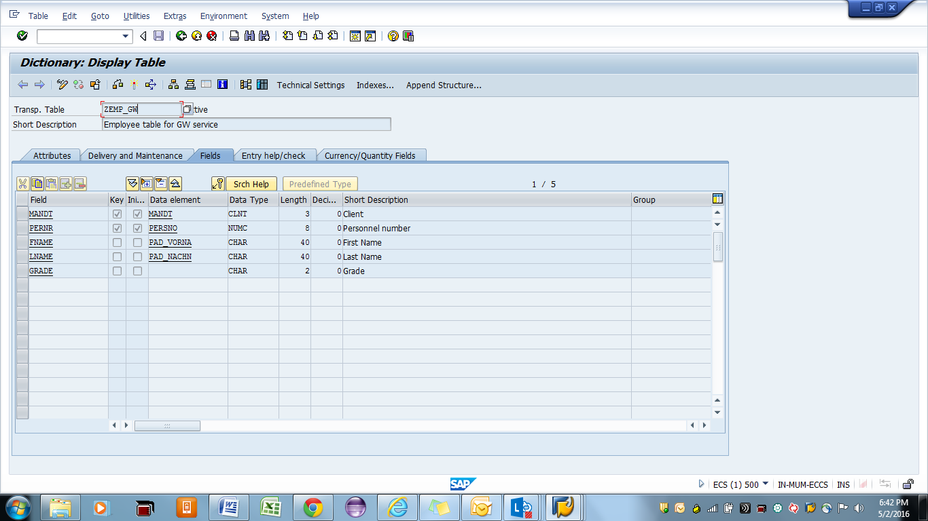

**Step 1:** Go to transaction code SEGW (SAP Netweaver Gateway Service Builder).

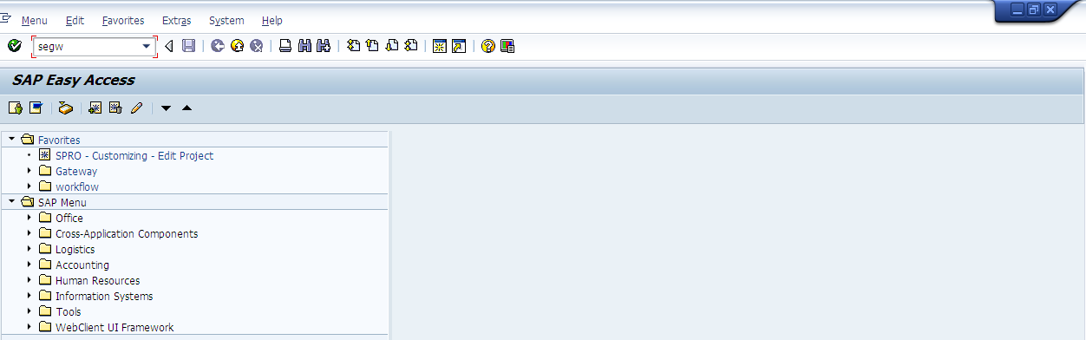

**Step 2:** Click on ‘Create Project’ button.

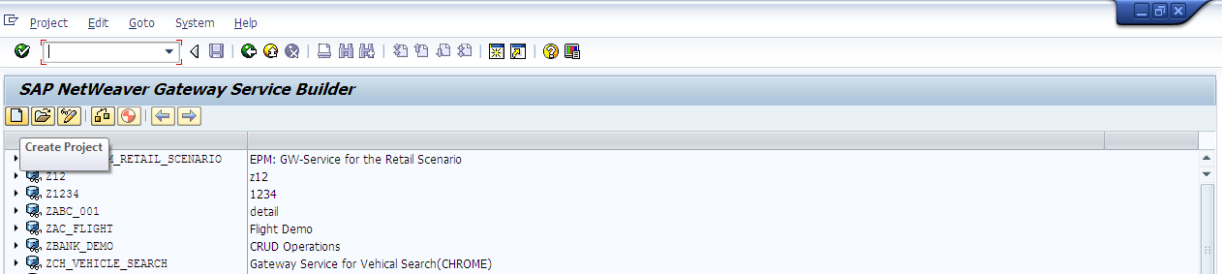

Provide a suitable project name and description. Provide a development package or save the project as a local object.

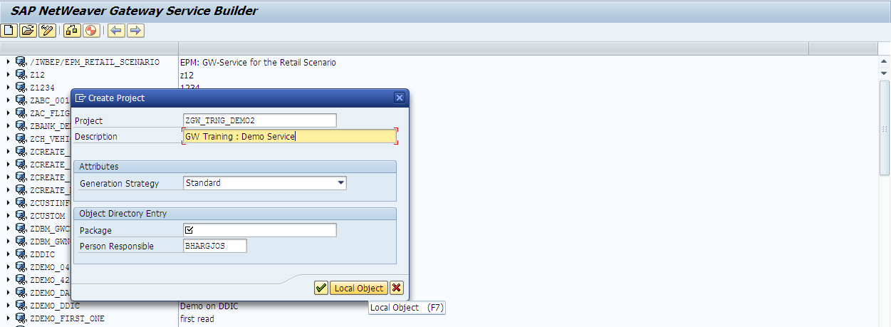

Save the project.

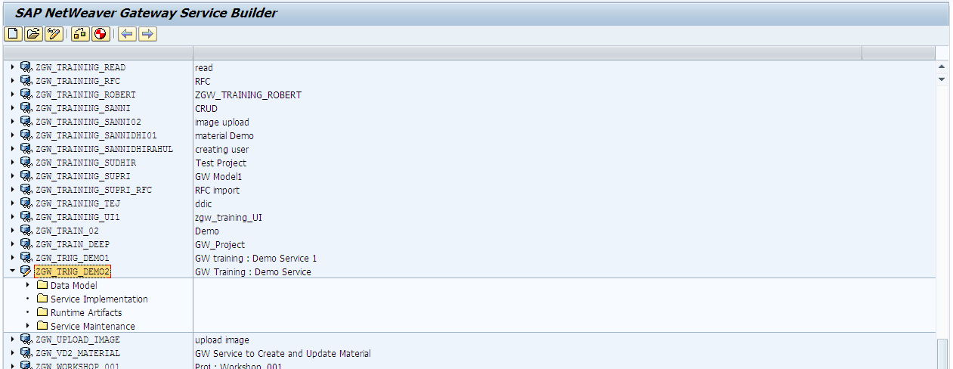

**Step 3:** Carry out the data model definition.

**Create Entity**

Right click on ‘Data Model’. Select ‘Import’, then select ‘DDIC Structure’. This option is selected bacause we aare creating an entity for employee record from the table ‘ZEMP_GW’.

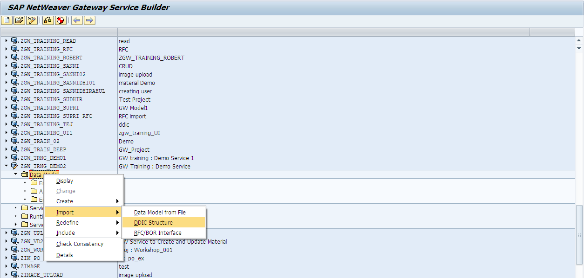

Provide the name of the table in the pop-up and click on enter. The fields of the table will be displayed. Also, provide the name of the entity that is to be created. In this case, the entity name is ‘Employee’. The field MANDT is to be ignored. The field Pernr is made as key.

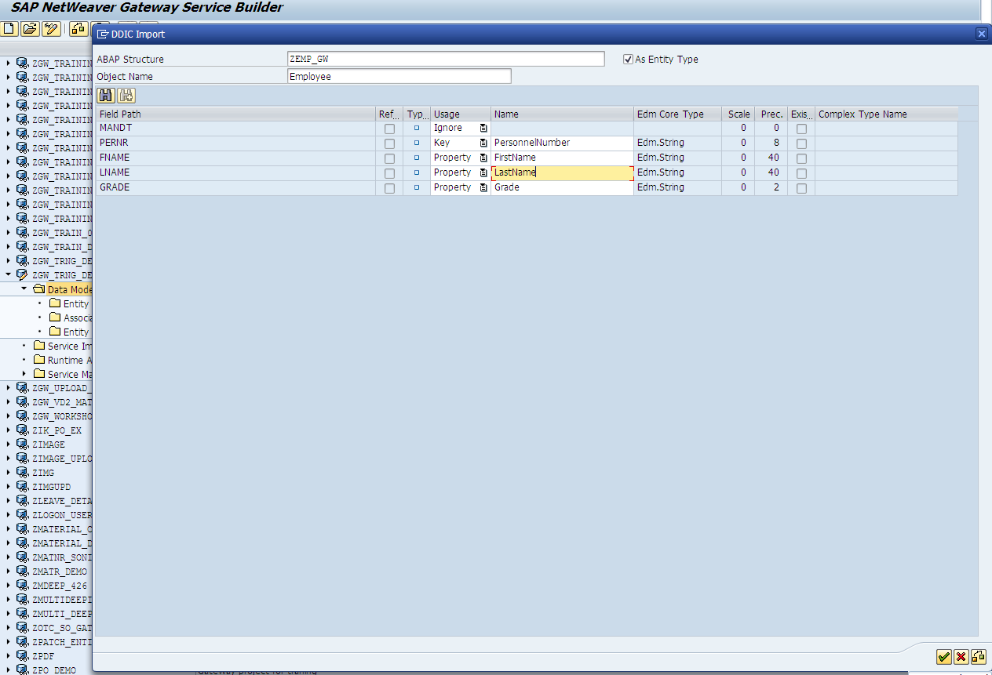

Click on the ‘OK’ button.

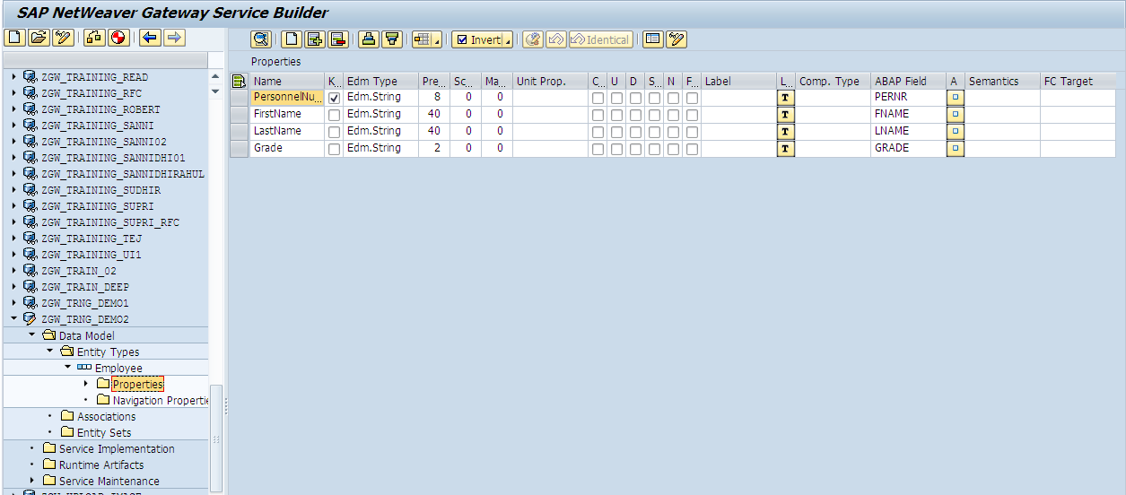

**Create Entity Set**

Right click on Entity Sets node. Select ‘Create’ option.

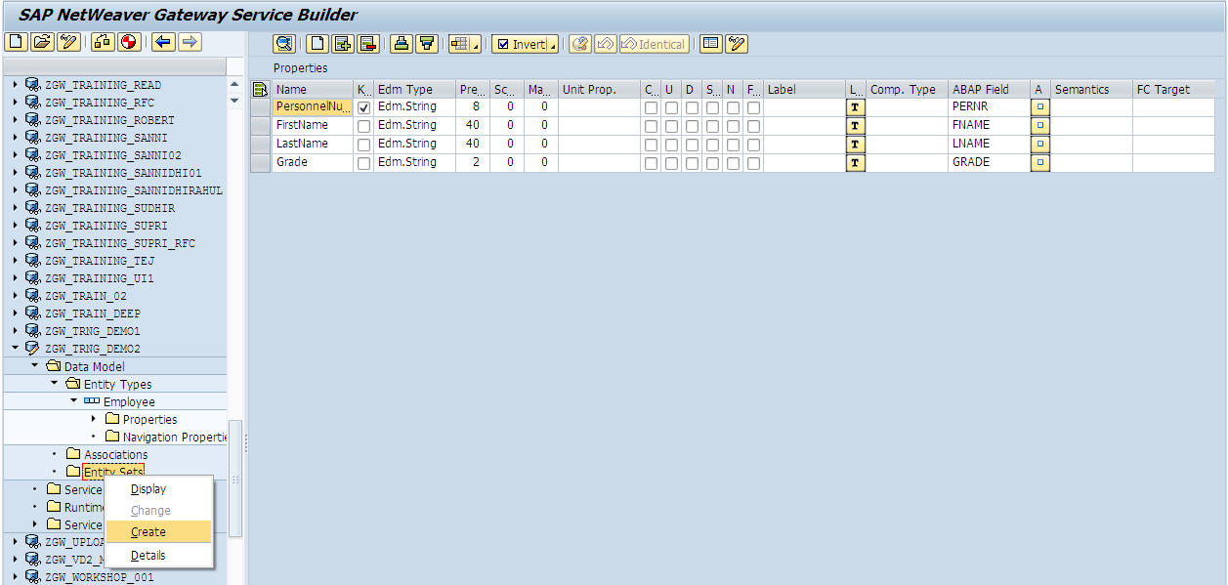

Provide a name to the entity set. Also select the entity for which the entity set is being created. In our case, the entity set is ‘EmployeeSet’ and its respective entity name is ‘Employee’.

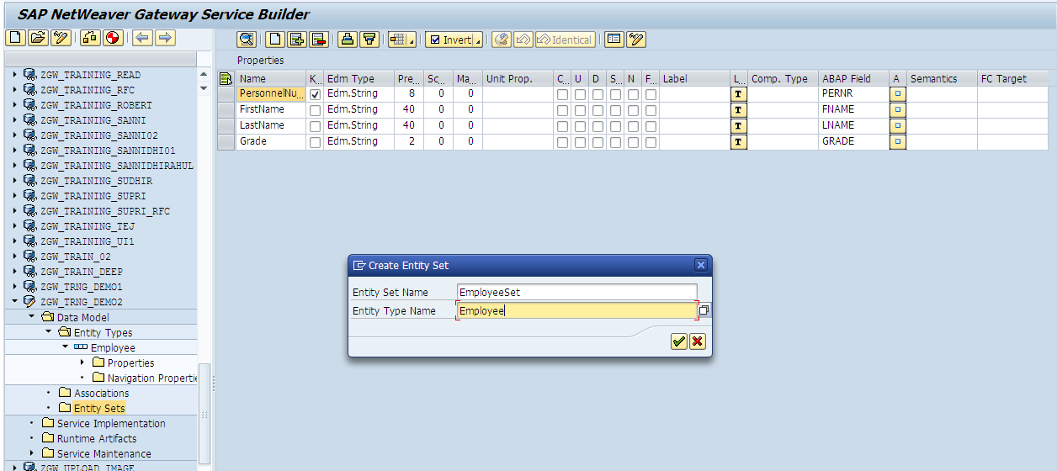

Click on ‘OK’ button.

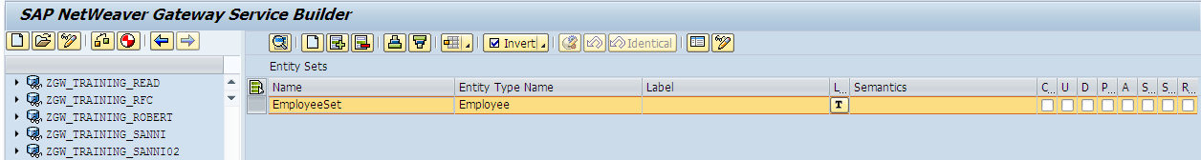

**Step 5: Generate & Maintain service**

Click on ‘Check Project Consistency’ button to check if there are any errors.

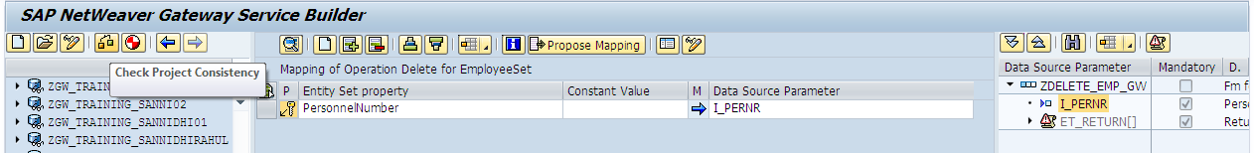

Click on ‘Generate Runtime Objects’ button to generate the runtime artifacts of the service. This will generate the MPC and DPC classes for the service.

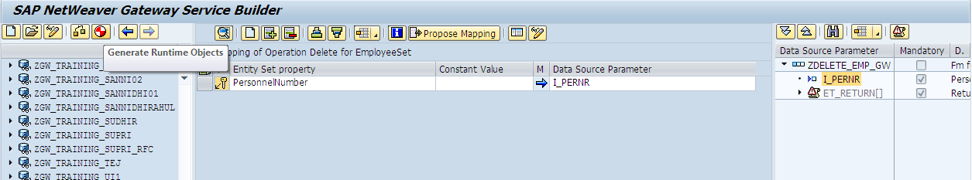

Click on CONTINUE button.

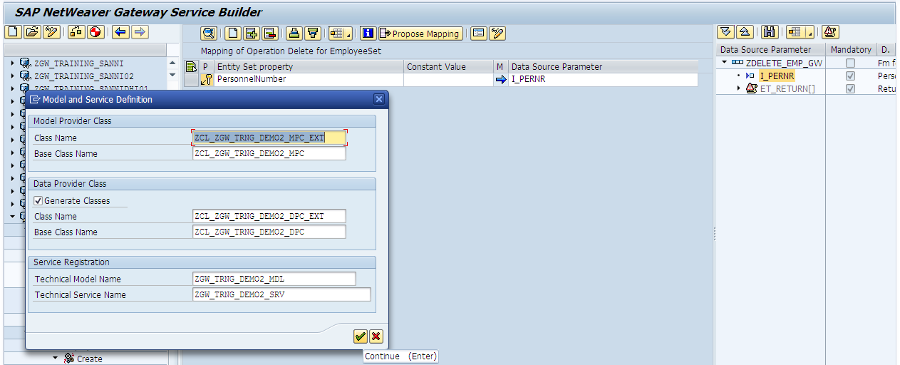

Provide the name of a development package or save it as a local object.

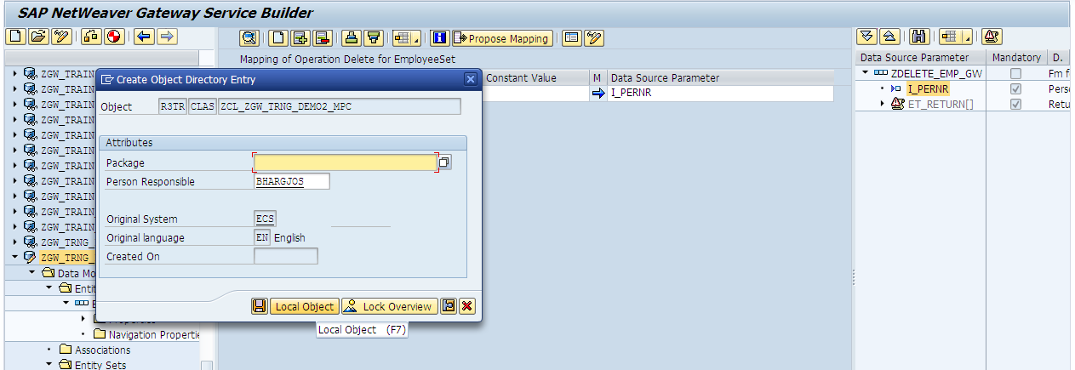

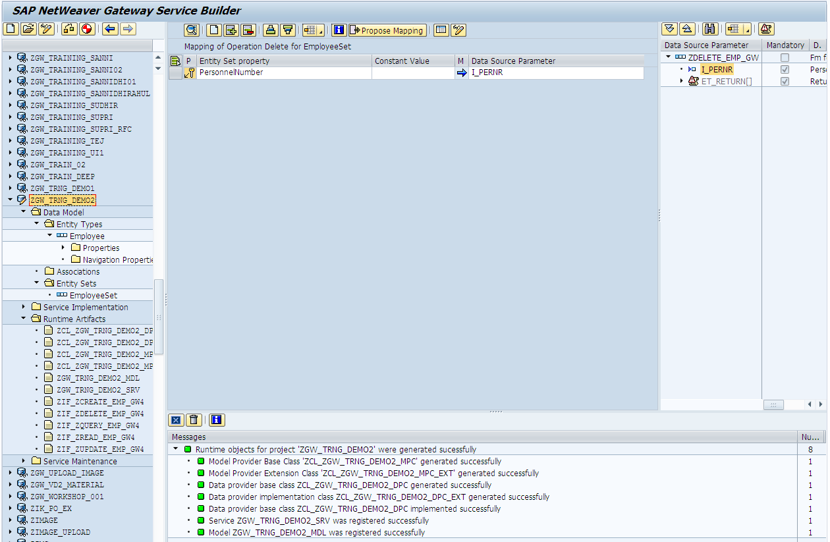

Double click on the ‘Service Maintenance’ node.

**Step 5:** Redefine the data provider class ext DPC_EXT with the CRUDQ methods of the entity set ‘EmployeeSet’.

**Get Entity Set/Query method**

Redefine the methods to be implemented and write the required code which suits the business case.

Redefine the method ZCL_ZGW_TRAINING_GATEW_DPC_EXT =>GET_ENTITYSET to fetch the list employees.

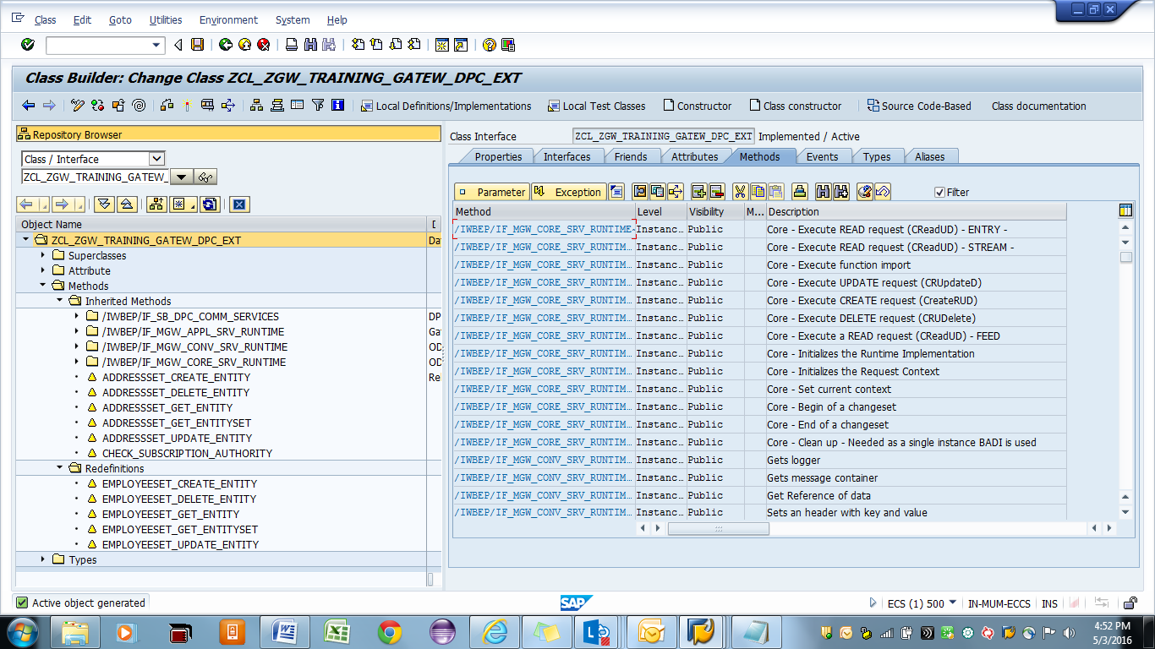

**URL:  
/sap/opu/odata/sap/ZGW_TRAINING_GATEWAY_SRV/EmployeeSet?$filter=Grade eq 'A'**

**Code for Get_entityset.**



**Get Entity/Read method**

Redefine the methods to be implemented and write the required code which suits the business case.

Redefine the method ZCL_ZGW_TRAINING_GATEW_DPC_EXT =>GET_ENTITY to single employe detail .



**URL:**

**/sap/opu/odata/sap/ZGW_TRAINING_GATEWAY_SRV/EmployeeSet(Pernr='1005')**

**Code For Get Entity:**



**Create method**

Redefine the methods to be implemented and write the required code which suits the business case.

Redefine the method ZCL_ZGW_TRAINING_GATEW_DPC_EXT =>CREATE_ENTITY to single employe detail.



Code for Create:



**Update method**

Redefine the methods to be implemented and write the required code which suits the business case.

Redefine the method ZCL_ZGW_TRAINING_GATEW_DPC_EXT =>UPDATE_ENTITY to single employe detail .



Code for Update:



**Delete method**

Redefine the methods to be implemented and write the required code which suits the business case.

Redefine the method ZCL_ZGW_TRAINING_GATEW_DPC_EXT =>DELETE_ENTITY to single employe detail .



Code for Delete:



Select the system alias to which the gateway system is to be connected. In our case, we select the LOCAL system alias as we follow an embedded arhitecture.

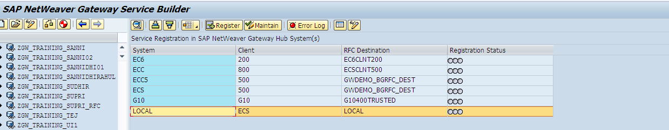

Click on ‘Register’ button.

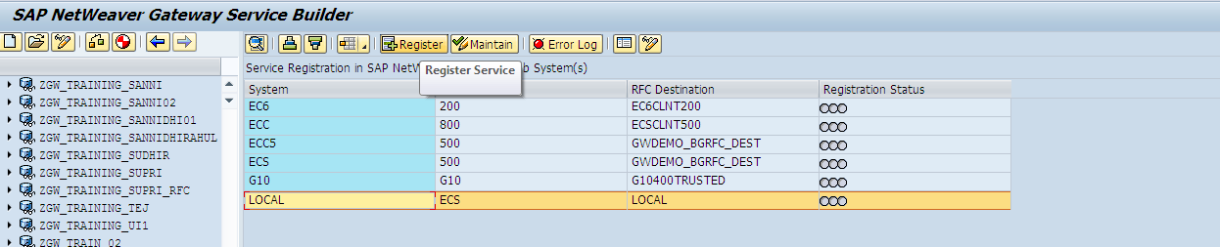

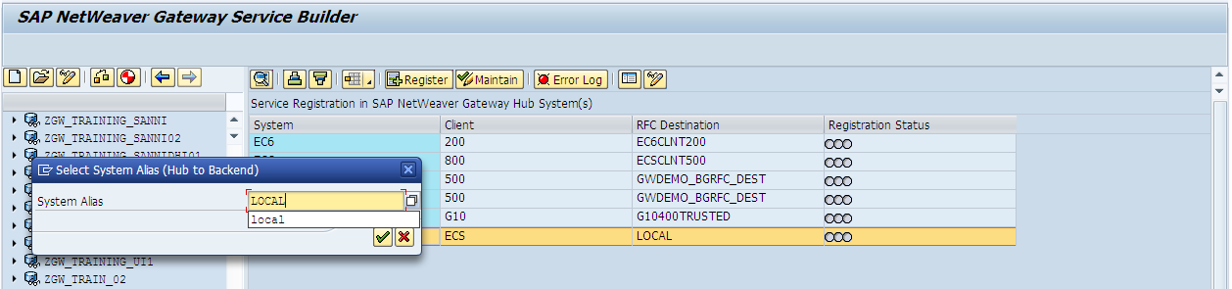

Provide a development package or sabve the service as a local object.

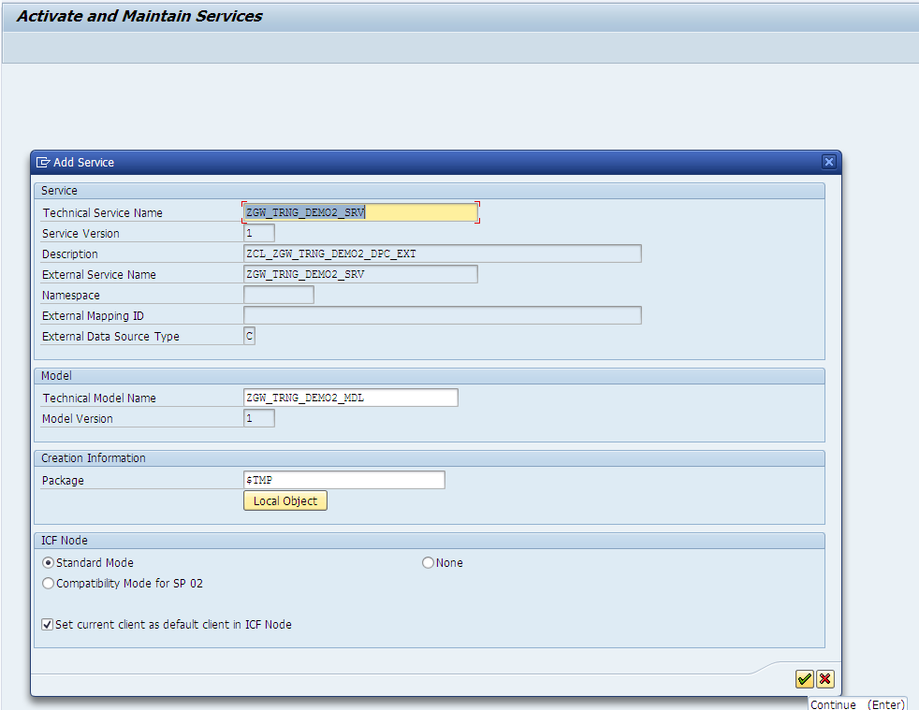

**Step 6:** Test the service in Gateway client.

Click on ‘Maintain’ button.

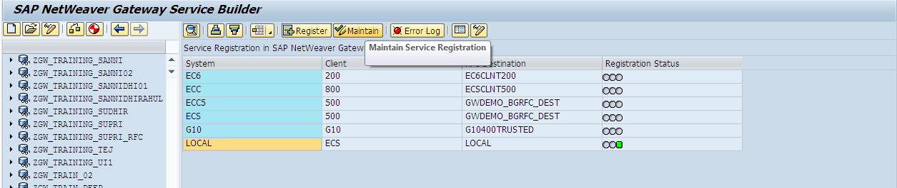

Click on ‘Gateway Client’ button.

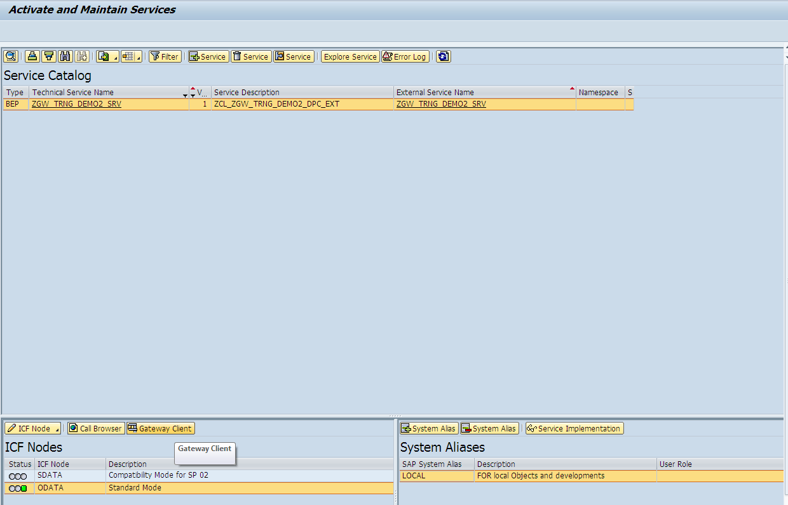

Check the service metadata.

**Service URI:** /sap/opu/odata/sap/ZGW_TRNG_DEMO2_SRV/$metadata

Click on execute.

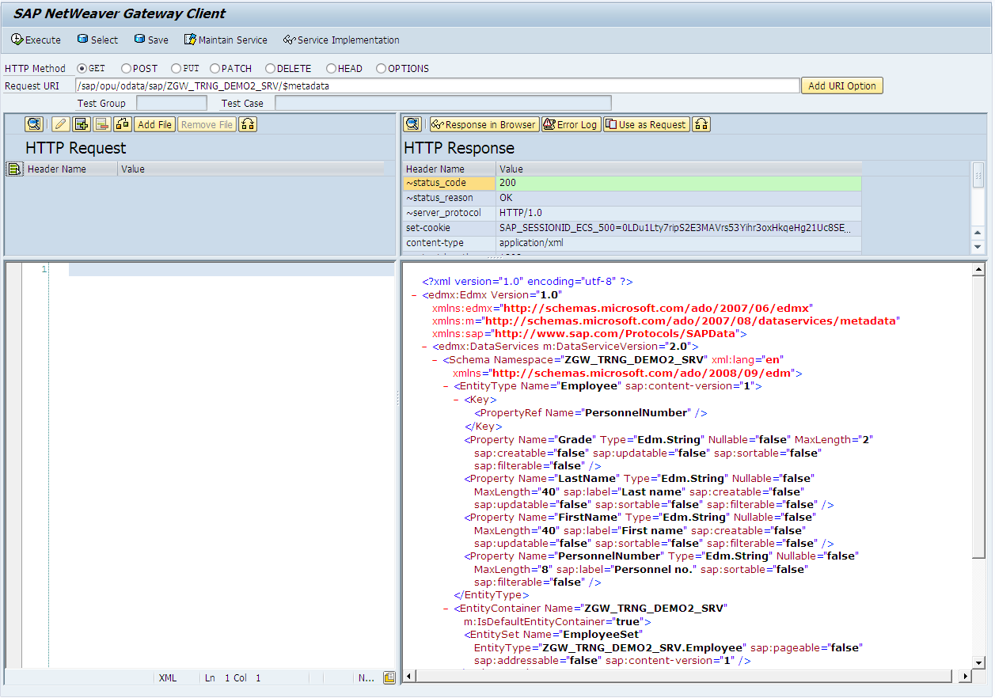

Test the Query operation.

**Service URI:** /sap/opu/odata/sap/ZGW_TRNG_DEMO2_SRV/EmployeeSet

**Operation:** GET

Test the Read operation.

**Service URI:** /sap/opu/odata/sap/ZGW_TRNG_DEMO2_SRV/EmployeeSet('00280004')

**Operation:** GET

Test the Create operation.

**Service URI:** /sap/opu/odata/sap/ZGW_TRAINING_GATEWAY_SRV/EmployeeSet

**Operation:** POST

**Payload:**

<atom:entry xmlns:atom="http://www.w3.org/2005/Atom">  
 <atom:content type="application/xml">  
  <m:properties xmlns:m="http://schemas.microsoft.com/ado/2007/08/dataservices/metadata" xmlns:d="http://schemas.microsoft.com/ado/2007/08/dataservices">  
   <d:Pernr>1007</d:Pernr>  
   <d:FirstName>Rahul</d:FirstName>  
   <d:LastName>Dave</d:LastName>  
   <d:Grade>B</d:Grade>  
  </m:properties>  
 </atom:content>  
</atom:entry>

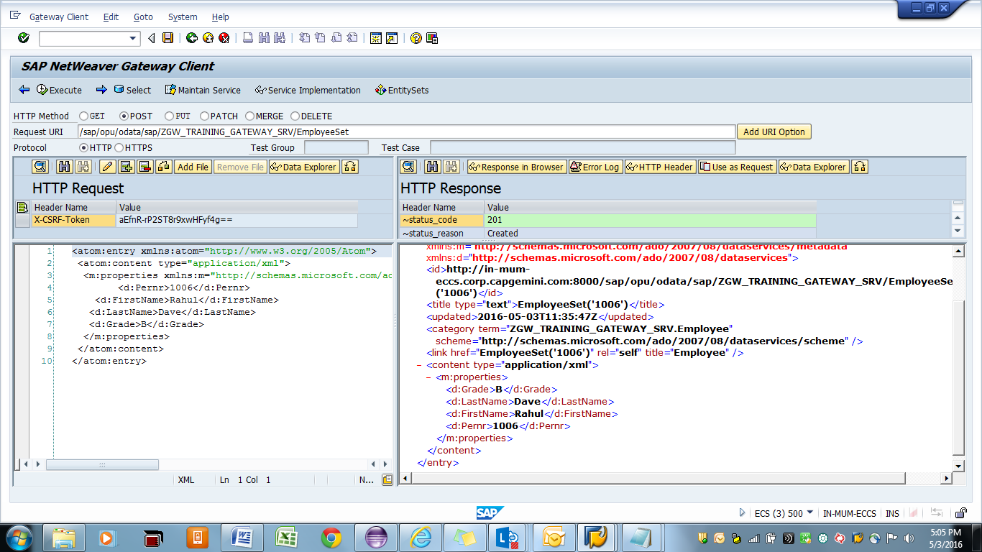

Test the Update operation.

**Service URI:** /sap/opu/odata/sap/ZGW_TRAINING_GATEWAY_SRV/EmployeeSet('1006')

**Operation:** PUT

**Payload:**

<atom:entry xmlns:atom="http://www.w3.org/2005/Atom">  
 <atom:content type="application/xml">  
  <m:properties xmlns:m="http://schemas.microsoft.com/ado/2007/08/dataservices/metadata" xmlns:d="http://schemas.microsoft.com/ado/2007/08/dataservices">  
        <d:Pernr>1006</d:Pernr>  
    <d:FirstName>Rahul</d:FirstName>  
   <d:LastName>Dave</d:LastName>  
   <d:Grade>A</d:Grade>  
  </m:properties>  
 </atom:content>  
</atom:entry>

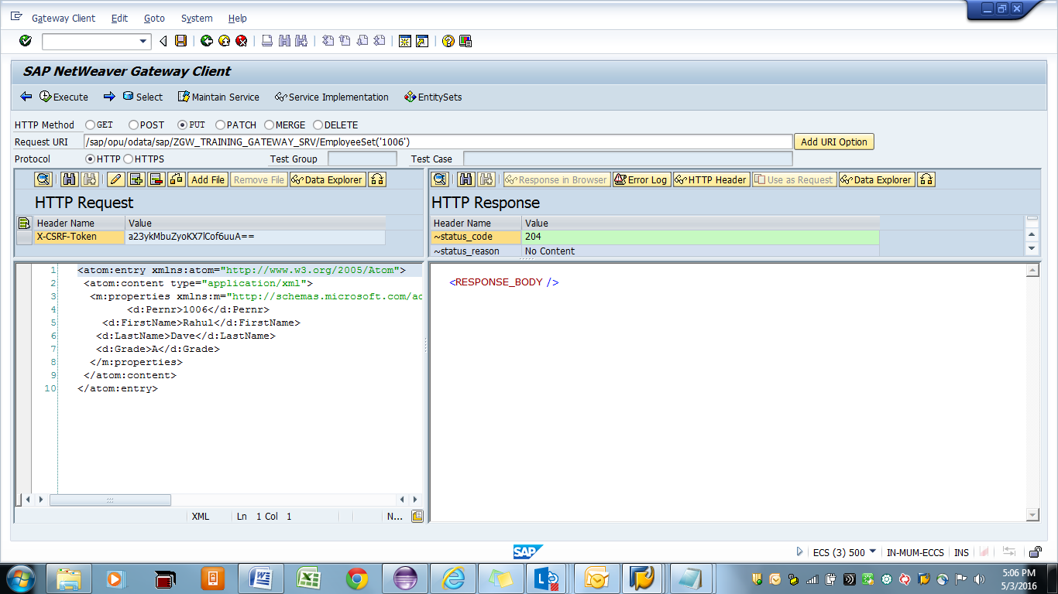

Test the Delete operation.

**Service URI:** /sap/opu/odata/sap/ZGW_TRAINING_GATEWAY_SRV/EmployeeSet('1006')

**Operation:** DELETE

